**Identifying Inequalities in Covid-19 Vaccination Uptake**

### 1. **Background**

The BNSSG CCG was challenged about the uptake of the COVID vaccines in the ‘healthy’ (i.e. non at-risk population) 25-29 year old age group. As part of a wider work on reducing inequalities in healthcare, it is important to understand what factors contribute to or may cause inequalities.

### 2. The Question

What patient attributes (especially demographic and geographical) are linked to or indicate differences or inequalities in Covid-19 vaccination uptake?

### 3. Approach

Vaccination data relating to vaccine doses received and Covid-19 risk was joined to the usual data used by the PHM ExploreR. Once complete, the tool was reloaded.

An analysis dataset was created consisting only of the 25-29 year old, non Covid at-risk population. Using this dataset, a decision tree was built targeting vaccine doses received. This identified attributes that indicated some inequalities in the selected population. To gather more variables that may be relevant, those identified by the first tree were removed from the attributes being used to build the decision tree, and the process was repeated.

This identified 8 patient attributes of interest, each of which was then used to segment the Analysis Dataset using the ‘Generalised Barcharts’ page. This revealed the distribution of vaccine doses received more accurately and was used to present the results to the project lead.

During this presentation and subsequent discussion, the ExploreR was used for further, live segmentation. To this end, further Analysis Datasets were created, each of which were then segmented by the various attributes identified previously for comparison. Some of these graphs were saved to be used in further discussions about the project. An example of one of these graphs can be found in Figure 1.

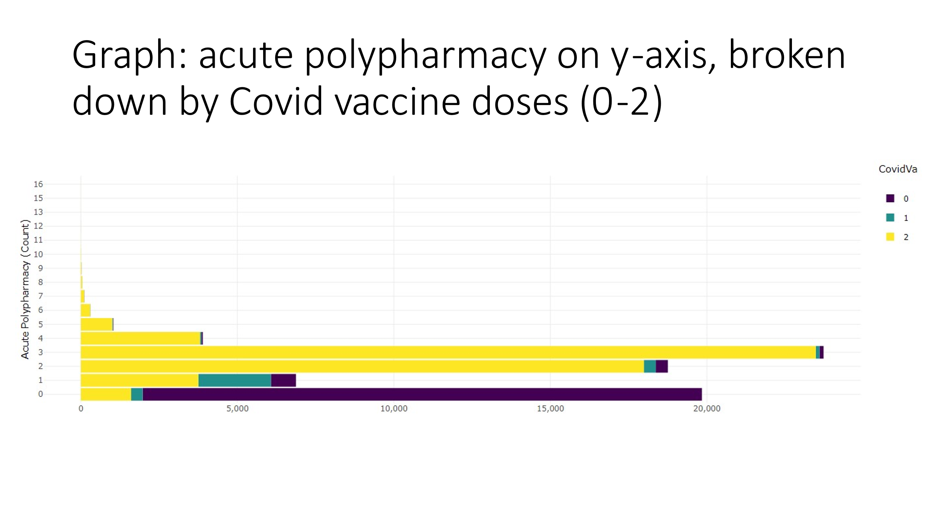

Figure 1: Acute Polypharmacy by Covid-19 vaccine doses. The graph shows the raw count of the population in each segment. Most of the population with 0 acute polypharmacy received no Covid-19 vaccine doses (purple).

### 4. Results

During the live segmentation, the clinical lead suggested a hypothesis that disproportionate numbers of women did not receive vaccines due to being pregnant. This theory was examined and was shown to be untrue. The several attributes identified as being significant for indicating differences in vaccination uptake were recorded along with multiple graph outputs of the ExploreR to be used in further discussion about this challengeChart, bar chart

Figure 2: Covid-19 vaccine uptake of female population segmented by receiving acute polypharmacy (‘Yes’ on y-axis) vs not receiving any acute polypharmacy (‘No’ on y-axis). Yellow: 2 doses, teal: 1 dose, purple: 0 doses. Clearly, a significantly higher proportion of ‘No’ acute polypharmacy did not receive any vaccine doses.

Figure 3: Covid-19 vaccine uptake of male population segmented by receiving acute polypharmacy (‘Yes’ on y-axis) vs not receiving any acute polypharmacy (‘No’ on y-axis). Yellow: 2 doses, teal: 1 dose, purple: 0 doses. Clearly, a significantly higher proportion of ‘No’ acute polypharmacy did not receive any vaccine doses.

### 5. Outcome

The ExploreR has been useful in confirming assumptions about who is coming forward the fastest and why for vaccinations. While this did not lead to immediate decisions (due to ‘background noise’ and system performance attributes also being discussed at the same time), the Managerial and Clinical Senior Responsible Officers found the results fascinating and have determined that wider sharing would surface more questions, and are working on fitting it into everyday business.